
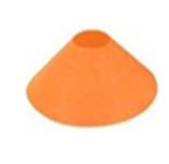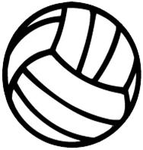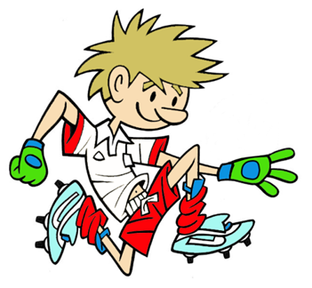 or

RULES – HOW TO PLAY

Start at cone, collect ball off cone

Jump over first hurdle

Slide under second hurdle

Throw ball into air or against wall b#and complete body catch

Return back over and under the hurdles

1 point for every complete go, without knocking poles off cones

Bonus point for successful catch

STATION 1: AGILITY
Activity: Over and Under the Bridges

Throw & Catch
FOCUS
Child can experience the concept of ‘over’ and ‘under’ as well as developing the body catch
HARDER
- Add in extra hurdles
- Reduce space between hurdles
- Bounce ball between jumps

EASIER
- Remove ball, just focus on hurdle activities
- Lower hurdle for jumping higher hurdle for going under

COACHING POINTS

HEAD
- Keep eyes on the ball until it is secured safely in chest
- Look at hurdles before travelling ‘over’ or ‘under’

HANDS
- Make hands bigger by spreading fingers when catching ball
- Lob ball up in front of face for a catch

FEET
- Run on the balls of your feet (front part)

EQUIPMENT

- Large Cones
- Poles
- Ball
- Dome

Copyright Ulster Council GAA 2009

